LAB 2

**Task 1**

Write a program that generates following result?

**Welcome to City University**

**Task 2**

Write a program that generates following result?

**Welcome**

**To**

**City University**

**Task 3**

Write a program that generates following result?

**Welcome**

**To**

**“City University”**

**Task 4**

Write program that add 2 integers? Arithmetic’s

**Task 5**

Write program that subtract 2 integers? Arithmetic’s

**Task 6**

Write program that multiply 2 integers? Arithmetic’s

**Task 7**

Write program that divide 2 integers? Arithmetic’s

**Task 8**

Write program that modules 2 integers? Arithmetic’s

**Task 9**

Produce following results using just cout statement?

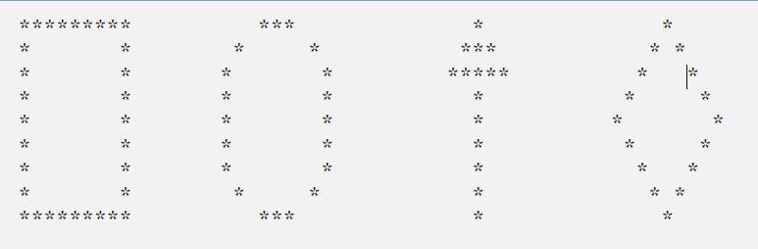

**Task 10**

Produce following results using just cout statement?



**Task 11**

Check following statement?

cout<<“*\n**\n***\n****\n*****\n”;

**Task 12**

What is your opinion about code as follow

If( x>5)

If(y>5)

cout<<”x and y are >5”;

else

cout<<”x is <=5”;

If( x>5)

{

If(y>5)

cout<<”x and y are >5”;

}

else

cout<<”x is <=5”;